Project 02

User Story 0002: Make my trip modified Logo

Description: The scope of this US is to make a new company logo. Check the modified logo in the mockup

Acceptance Criteria:
    - Upon clicking on the ‘Explore the World’ link system will navigate to Where2Go- by MakeMyTrip page.
    - Where2Go- by MakeMyTrip page will be open in a new window/tab.
    - Browser title should display: “Where2Go by Make my trip | Explore Destination | Plan your trip”.

Mockup:

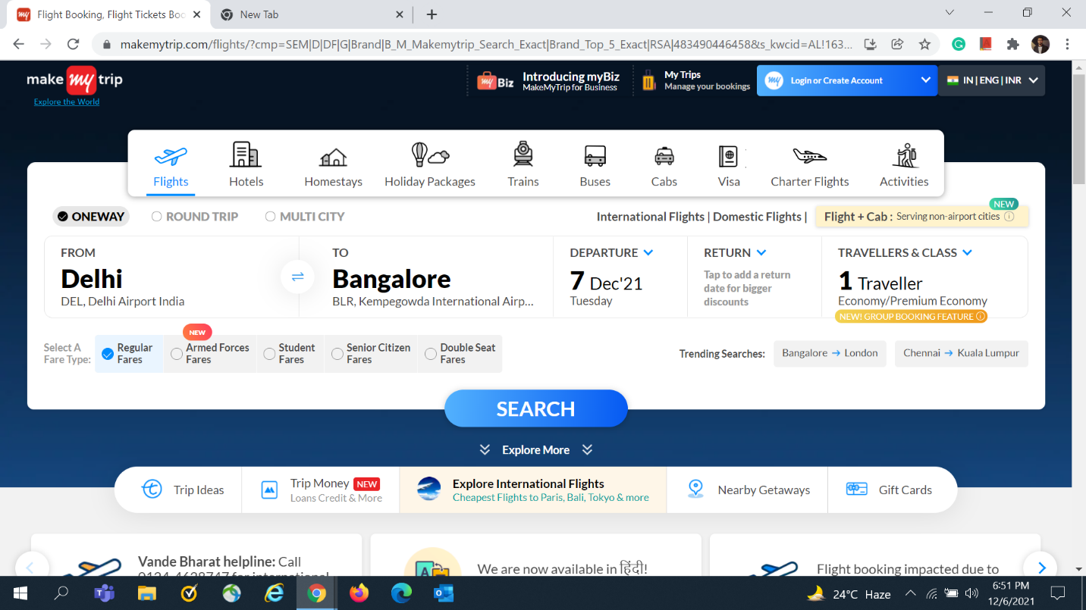

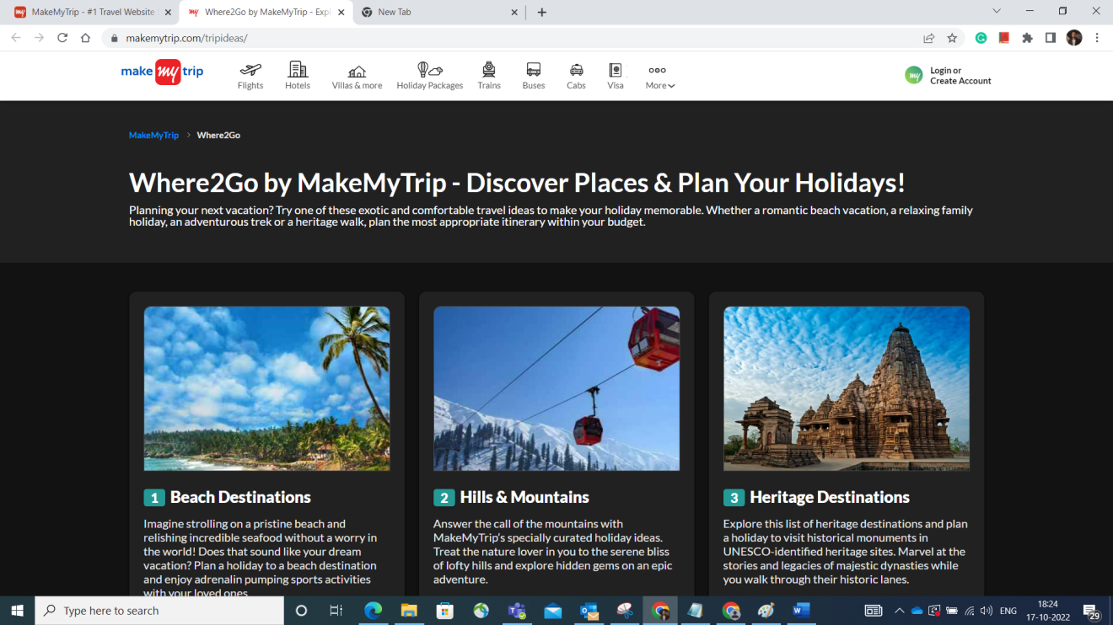
STAFF DEBUG INFO

Instructions

In the Make My Trip application client wants to change the Logo they want to add the link (i.e.. Explore the World) after the Logo Please find the new logo in the user story mockup and complete all the subtasks.

Subtasks

- Write the test scenario and cases based on the acceptance criteria for the newly implemented functionality.
- While testing the functionality you found one observation when user click on ‘Explore the world’ link system is throwing Unauthorized error raise the bug and provide the below details:

Priority of the bug
Bug title
Steps to reproduce
Actual Result
Expected Result

